2.4: The eastward run takes 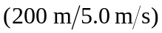 = 40.0 s and the westward run takes 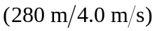 = 70.0 s. a) (200 m + 280 m)/(40.0 s + 70.0 s) = 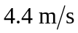 to two significant figures. b) The net displacement is 80 m west, so the average velocity is 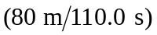 = 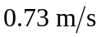 in the –x-direction 